(a) Write program in assembly language to print single character on screen.

Code

ORG 100h

MOV DX, OFFSET msg_input

MOV AH, 09h

INT 21h

MOV AH, 01h

INT 21h

MOV BL, AL

MOV DX, OFFSET msg_output

MOV AH, 09h

INT 21h

MOV DL, BL

MOV AH, 02h

INT 21h

MOV AH, 4Ch

INT 21h

msg_input DB 'Enter a single character: $'

msg_output DB 0Dh, 0Ah, 'The single character is: $'

END

Output:

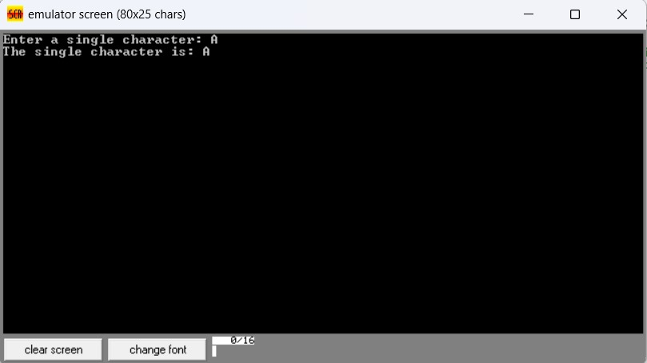

(b) Write an assembly language program to convert an upper-case letter to the

corresponding lower-case letter.

org 100h

; display input message

mov dx, offset msg_input

mov ah, 09h

int 21h

; read character

mov ah, 01h

int 21h

mov dl, al

mov bl, al

; check if the character is an uppercase letter

cmp al, 'A'

jl notuppercase

cmp al, 'Z'

jg notuppercase

; convert uppercase to lowercase

add bl, 20h

;print the output message

mov dx, offset msg_output

mov ah, 09h

int 21h

; print the converted lowercase letter

mov dl, bl

mov ah, 02h ; 02h to print a single character

int 21h

jmp endprogram

notuppercase:

; print the error message

mov dx, offset msg_error

mov ah, 09h

int 21h

endprogram:

; end the program

mov ah, 4Ch

int 21h

; data segment

msg_input db 'Enter an uppercase: $'

msg_output db 0dh, 0ah, 'The lowercase letter is: $'

msg_error db 0dh, 0ah, 'Error: Not an uppercase! $'

Output: 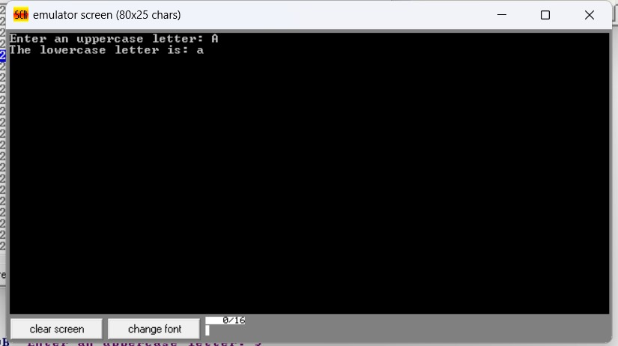

Practice set:

2.

(a) Write a program in assembly language to print multiple characters on screen.

Code

. ORG 100h

MOV DX, OFFSET msg_input

MOV AH, 09h

INT 21h

MOV CX, 0Ah

MOV DI, OFFSET user_input

ReadChar:

MOV AH, 01h

INT 21h

CMP AL, 0Dh

JE DoneReading

MOV [DI], AL

INC DI

LOOP ReadChar

DoneReading:

MOV BYTE PTR [DI], '$'

MOV DX, OFFSET msg

MOV AH, 09h

INT 21h

MOV DX, OFFSET user_input

MOV AH, 09h

INT 21h

MOV AH, 4Ch

INT 21h

msg_input DB 'Enter multiple characters: $'

msg DB 0Dh, 0Ah, 'The multiple characters are: $'

user_input DB 10 DUP (?)

END

Output:

(b) Write an assembly language program to convert a lower-case letter to the

corresponding upper-case letter.

Code

ORG 100h

MOV DX, OFFSET msg_input

MOV AH, 09h

INT 21h

MOV AH, 01h

INT 21h

MOV DL,AL

MOV BL, AL

CMP AL, 'A'

JL NotUpperCase

CMP AL, 'Z'

JG NotUpperCase

ADD BL, 20h

MOV DX, OFFSET msg_output

MOV AH, 09h

INT 21h

MOV DL, BL

MOV AH, 02h

INT 21h

JMP EndProgram

NotUpperCase:

MOV DX, OFFSET msg_error

MOV AH, 09h

INT 21h

EndProgram:

MOV AH, 4Ch

INT 21h

msg_input DB 'Enter an uppercase letter: $'

msg_output DB 0Dh, 0Ah, 'The lowercase letter is: $'

msg_error DB 0Dh, 0Ah, 'Error: Not an uppercase letter! $'

END

Output:

